Index
Program 1: C program to check whether a given no is Armstrong no.
Program 2: C program to check whether a given no is perfect or not.
Program 3: C program to calculate the prime numbers between 1 to 100.
Program 4: C program to print the following pattern.
Program 5: C program to print the following pattern.
Program 6: C program to print the following pattern.
Program 7: C program to search an element from an array and display the location of the element in the array.
Program 8: C program to calculate the minimum, maximum, sum, average of a series of numbers terminating by 0.
Program 9: C program that will delete all duplicate values in an array.
Program 10: C program to insert two matrices at runtime and perform a matrix addition.
Program 11: C program to take a sentence from user and find total no of words, vowels, digits, other character and spaces in that sentence.
Program 12: C program to check whether a given word is palindrome or not.
Program 13: C program to convert a given string from lower case to upper case.
Program 14: C program to sort an array given by the user.
Program 15: C program to calculate the factorial of a no using recursion.
Program 16: C program to convert a decimal no to its equivalent binary no using function call.
Program 17: C program to swap the values of two variables using function call.
Program 18: C program to print the Fibonacci series between 1 to n using function call.
Program 19: C program to store and display the details of a book using structure.
Program 20: C program to store items and find the name of the item with maximum quantity in the store using structure.

SODEPUR HIGH SCHOOL (H.S)



NAME:- DATTATREYA DINDA
CLASS :- 11 (SCIENCE)
ROLL:- 74
REGISTRATION NO. :-
Subject: Computer Science

Program 1: C program to check whether a given no is Armstrong or not.
#include <stdio.h>
int main()
{
int n,r,s=0,temp;
printf ("\n enter a number");
scanf ("%d",&n);
temp=n;
while (n!=0)
{r=n%10;
s=s+(r*r*r);
n=n/10;
}
if (temp==s)
printf ("\n armstrong no");
else
printf ("\n not armstrong no");
return 0;
}

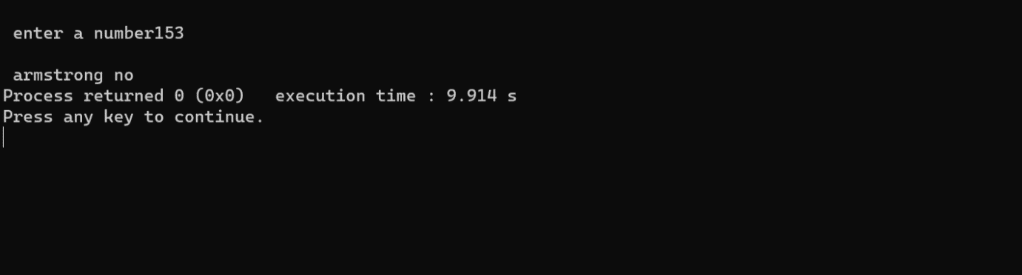

Program 2: C program to check whether a given no is perfect or not.
#include <stdio.h>
int main()
{
int num, i, sum = 0;
printf("Enter a number: ");
scanf("%d", &num);
for (i = 1; i < num; i++)
{
if (num % i == 0)
{
sum += i;
}
}
if (sum == num) {
printf("%d is a perfect number\n", num);
}
else {
printf("%d is not a perfect number\n", num);
}
return 0;
}

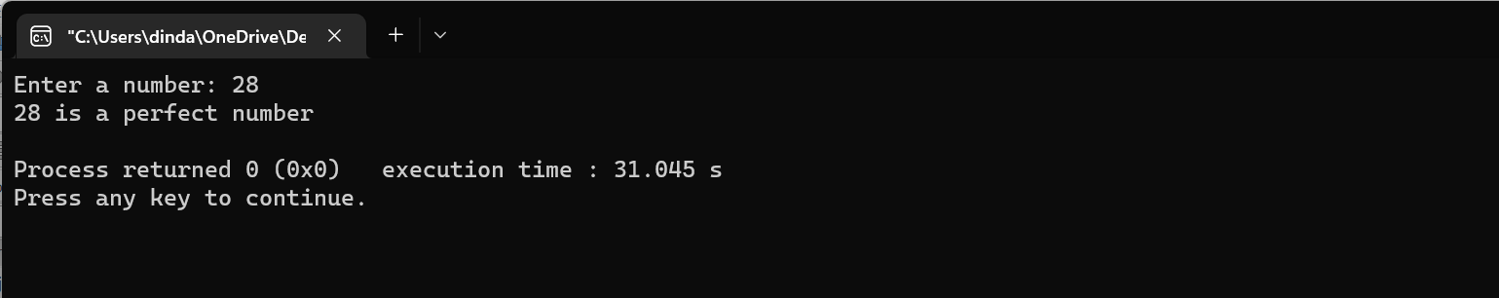

Program 3: C program to calculate the prime numbers between 1 to 100
#include <stdio.h>

int main() {
int i, j;

printf("Prime numbers between 1 to 100 are: \n");
for(i = 2; i <= 100; i++) {
int isPrime = 1;
for(j = 2; j <= i/2; j++) {
if(i % j == 0) {
isPrime = 0;
break;
}
}
if(isPrime) {
printf("%d\n", i);
}
}
return 0;
}

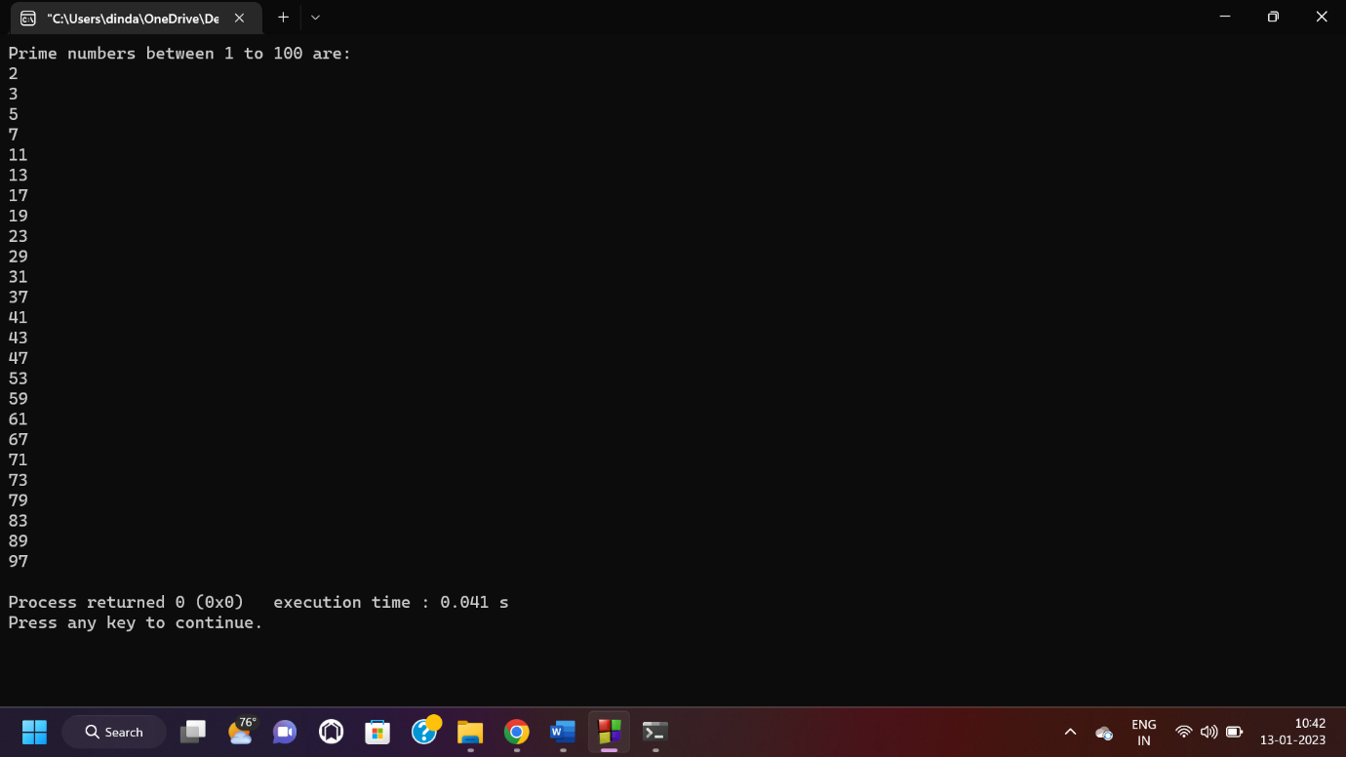

Program 4 : C program to print the following pattern.
#include <stdio.h>
int main() {
int i,j,n;
printf ("\n print how many times ",n);
scanf ("%d",&n);
for (int i = 0; i < n; i++) {
for (int j = 0; j < i; j++) {
printf(" ");
}

for (int j = 0; j < n - i; j++) {
printf("*");
}

printf("\n");
}

return 0;
}

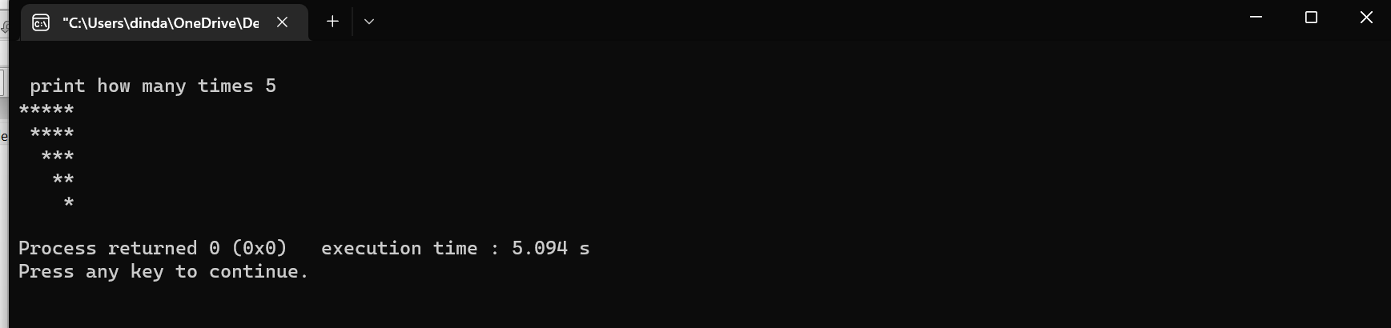

Program 5: C program to print the following pattern.
#include <stdio.h>
int main() {
int i, space, rows, k = 0;
printf("Enter the number of rows: ");
scanf("%d", &rows);
for (i = 1; i <= rows; ++i, k = 0) {
for (space = 1; space <= rows - i; ++space) {
printf(" ");
}
while (k != 2 * i - 1) {
printf("* ");
++k;
}
printf("\n");
}
return 0;
}

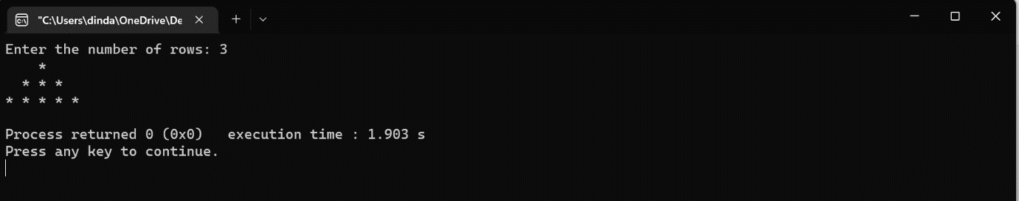

Program 6: C program to print the following pattern.
#include <stdio.h>
int main()
{int i,j,n,k=1;
printf ("\n how many time");
scanf ("%d",&n);
for (i=1;i<=n;i++)
{
for (j=1;j<=i;j++)
printf ("%d ",k++);
printf ("\n");}
return 0;
}

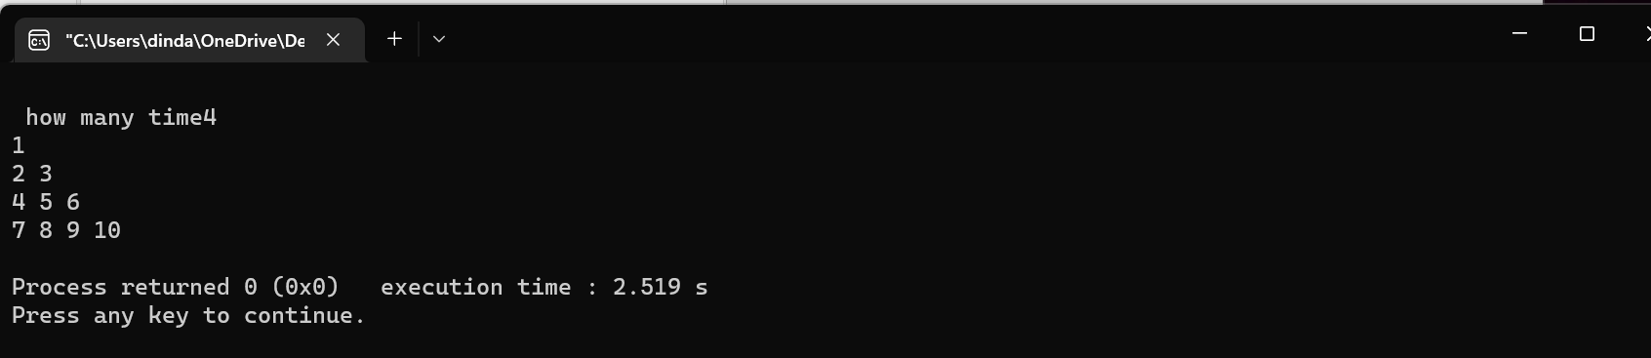

Program 7: C program to search an element from an array and display the location of the element in the array.
#include <stdio.h>
int main()
{int a[5],i,k,fl=0;
printf ("\n enter array element \n");
for (i=0;i<5;i++)
scanf ("%d",&a[i]);
printf ("\n enter the value to search:");
scanf ("%d",&k);
for (i=0;i<5;i++)
{if (a[i]==k)
{fl=1;
break;
}
}
if (fl==1)
printf ("\n value found at %d location",(i+1));
else
printf ("\n value not found");
return 0;
}

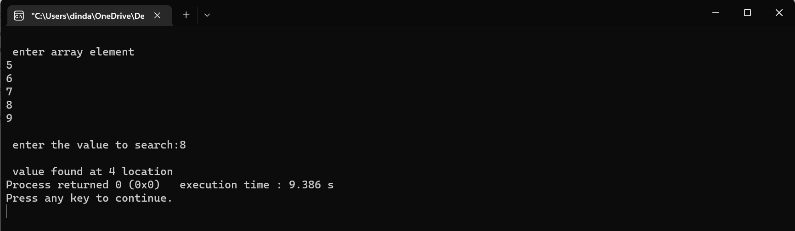

Program 8 : C program to calculate the minimum, maximum, sum, average of a series of numbers terminating by 0.
#include <stdio.h>
int main()
{int num,max,min,sum=0,count=0;
float av=0.0;
printf ("\n enter a number");
scanf ("%d",&num);
max=min=num;
while (num!=0)
{if (num>max)
max=num;
if (num<min)
min=num;
sum=sum+num;
count++;
printf ("\n enter a no");
scanf ("%d",&num);
}
printf ("\n max =%d",max);
printf ("\n min =%d",min);
printf ("\n sum =%d",sum);
printf ("\n avg =%f",(float)sum/count);
return 0;
}

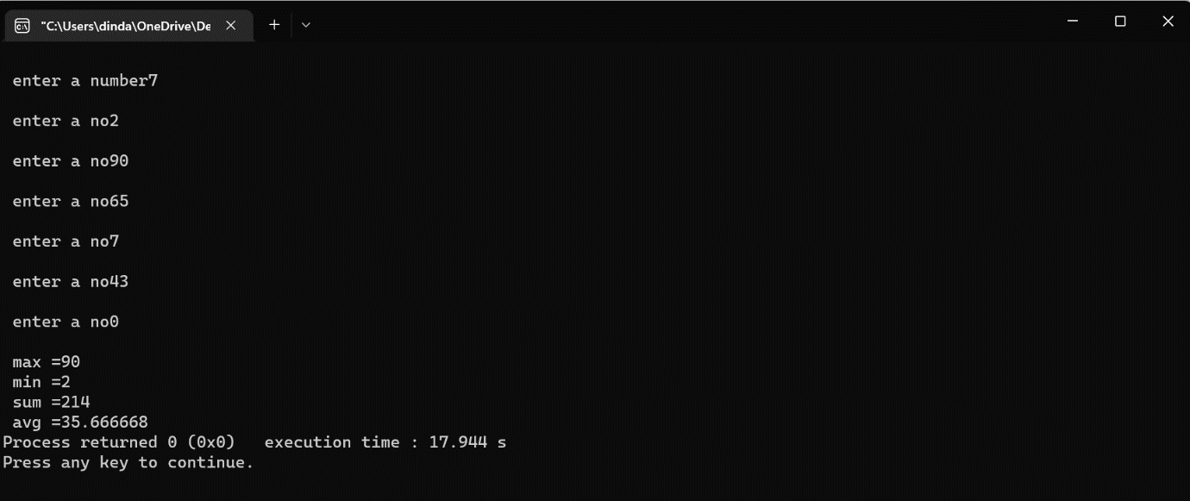

Program 9: C program that will delete all duplicate values in an array.
#include <stdio.h>
#include <conio.h>
int main ()
{
int arr[20], i, j, k, size;
printf (" Define the number of elements in an array: ");
scanf (" %d", &size);

printf (" \n Enter %d elements of an array: \n ", size);
for ( i = 0; i < size; i++)
{
scanf (" %d", &arr[i]);
}

for ( i = 0; i < size; i ++)
{
for ( j = i + 1; j < size; j++)
{

if ( arr[i] == arr[j])
{

for ( k = j; k < size - 1; k++)
{
arr[k] = arr [k + 1];
}

size--;
j--;
}
}
}

printf (" \n Array elements after deletion of the duplicate elements: ");

for ( i = 0; i < size; i++)
{
printf (" %d \t", arr[i]);
}
return 0;
}

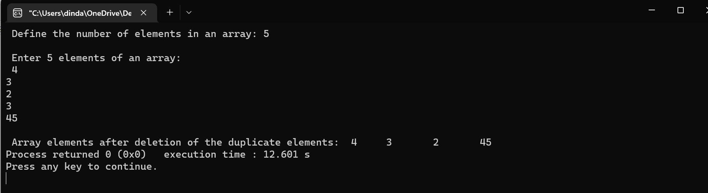

Program 10: C program to insert two matrices at run time and perform a matrix addition.
#include<stdio.h>
int main()
{
int mat1[2][2],mat2[2][2],mat3[2][2],i,j;
printf("\nEnter 1st matrix Elements ");
for(i=0;i<2;i++)
{
for(j=0;j<2;j++)
{
scanf("%d",&mat1[i][j]);
}
}

printf("\nEnter 2nd matrix Elements ");
for(i=0;i<2;i++)
{
for(j=0;j<2;j++)
{
scanf("%d",&mat2[i][j]);
}
}

for(i=0;i<2;i++)
{
for(j=0;j<2;j++)
{
mat3[i][j]=mat1[i][j]+mat2[i][j];
}
}

printf("\n 1st matrix Elements are \n ");
for(i=0;i<2;i++)
{
for(j=0;j<2;j++)
{
printf("%d\t",mat1[i][j]);
}
printf("\n\n");
}
printf("\n 2ndt matrix Elements are \n ");
for(i=0;i<2;i++)
{
for(j=0;j<2;j++)
{
printf("%d\t",mat2[i][j]);
}
printf("\n\n");
}

printf("\n 3rd matrix Elements are \n ");
for(i=0;i<2;i++)
{
for(j=0;j<2;j++)
{
printf("%d\t",mat3[i][j]);
}
printf("\n\n");
}

return 0;}
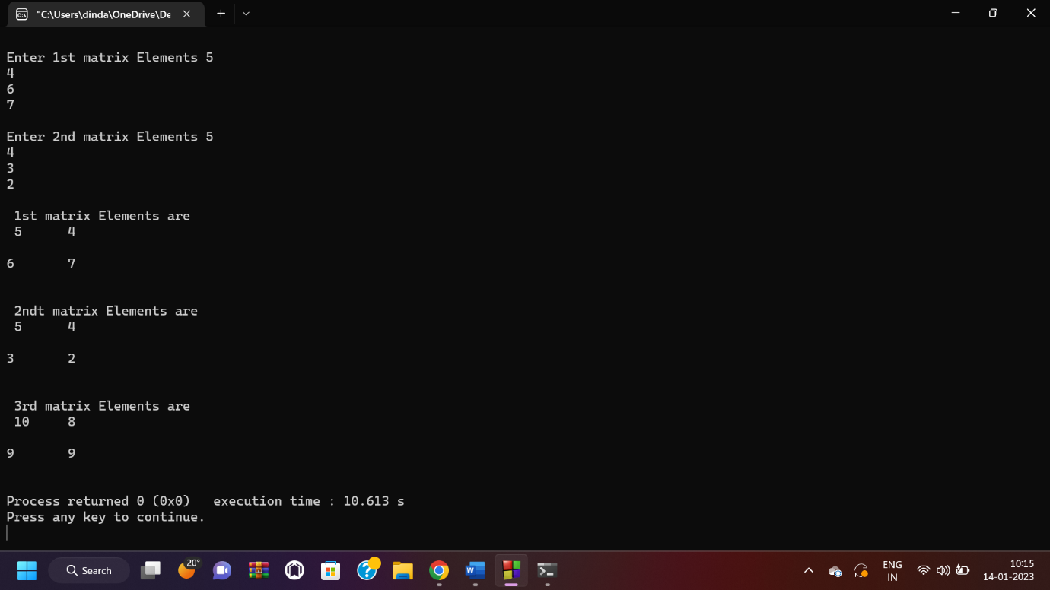

Program 11: C program to take a sentence from user and find total no of words, vowels, digits, other character and spaces in that sentence.
#include <stdio.h>
#include <ctype.h>

int main() {
char sentence[1000];
int i, vowels = 0, digits = 0, others = 0, spaces = 0, words = 1;

printf("Enter a sentence: ");
gets(sentence);

for (i = 0; sentence[i]; i++) {
if (isalpha(sentence[i])) {
if (sentence[i] == 'a' || sentence[i] == 'e' || sentence[i] == 'i' ||
sentence[i] == 'o' || sentence[i] == 'u' || sentence[i] == 'A' ||
sentence[i] == 'E' || sentence[i] == 'I' || sentence[i] == 'O' ||
sentence[i] == 'U') {
vowels++;
}
} else if (isdigit(sentence[i])) {
digits++;
} else if (isspace(sentence[i])) {
spaces++;
if(sentence[i+1] != '\0')
words++;
} else {
others++;
}
}

printf("Total number of vowels: %d\n", vowels);
printf("Total number of digits: %d\n", digits);
printf("Total number of other characters: %d\n", others);
printf("Total number of spaces: %d\n", spaces);
printf("Total number of words: %d\n", words);

return 0;
}
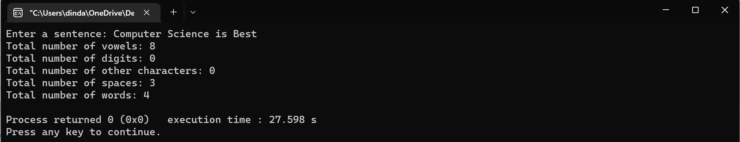

Program 12: C program to check whether a given word is palindrome or not.
#include <stdio.h>
#include <string.h>

int main() {
char word[100];
int i, j, len;
int isPalindrome = 1;

printf("Enter a word: ");
scanf("%s", word);

len = strlen(word);

for (i = 0, j = len - 1; i < j; i++, j--) {
if (word[i] != word[j]) {
isPalindrome = 0;
break;
}
}

if (isPalindrome) {
printf("'%s' is a palindrome.\n", word);
} else {
printf("'%s' is not a palindrome.\n", word);
}

return 0;
}

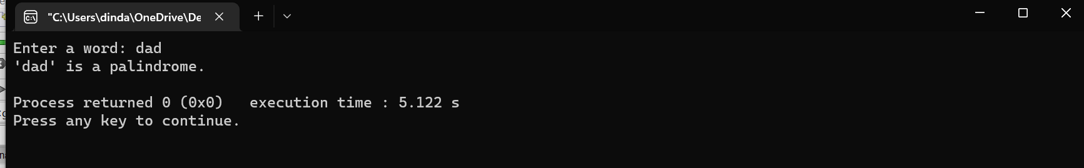

Program 13: C program to convert a given string from lower case to upper case.
#include <stdio.h>

int main() {
char str[100];
int i;

printf("Enter a string in lower case: ");
scanf("%s", str);

for (i = 0; str[i]; i++) {
if (str[i] >= 'a' && str[i] <= 'z') {
str[i] = str[i] - 32;
}
}

printf("Upper case string: %s\n", str);

return 0;
}

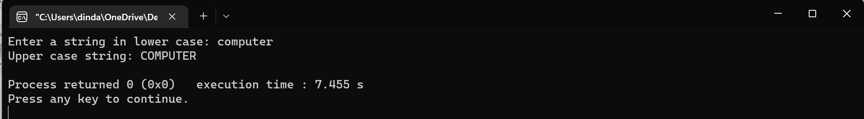

Program 14: C program to sort an array given by the user.
#include <stdio.h>

void bubbleSort(int arr[], int n) {
int i, j, temp;
for (i = 0; i < n-1; i++) {
for (j = 0; j < n-i-1; j++) {
if (arr[j] > arr[j+1]) {
temp = arr[j];
arr[j] = arr[j+1];
arr[j+1] = temp;
}
}
}
}

int main() {
int arr[100], n, i;

printf("Enter the number of elements in the array: ");
scanf("%d", &n);

printf("Enter the elements of the array: ");
for (i = 0; i < n; i++) {
scanf("%d", &arr[i]);
}

bubbleSort(arr, n);

printf("Sorted array: ");
for (i = 0; i < n; i++) {
printf("%d ", arr[i]);
}
return 0;
}

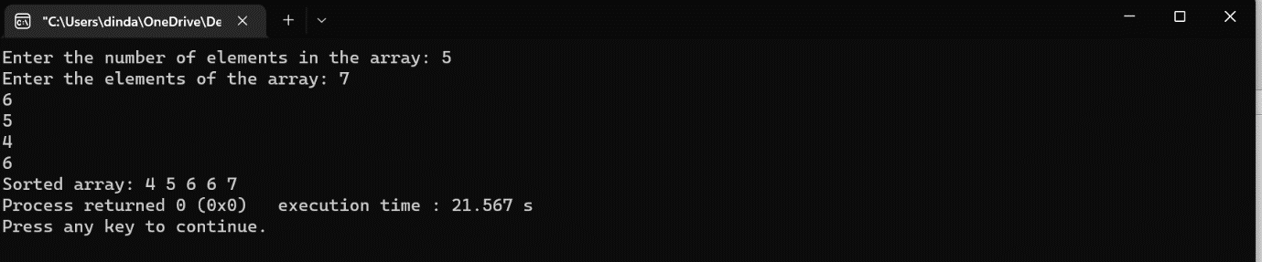

Program 15: C program to calculate the factorial of a no using recursion.
#include <stdio.h>

int factorial(int n) {
if (n == 0) {
return 1;
}
return n * factorial(n-1);
}

int main() {
int num;
printf("Enter a number: ");
scanf("%d", &num);
printf("Factorial of %d is %d", num, factorial(num));
return 0;
}

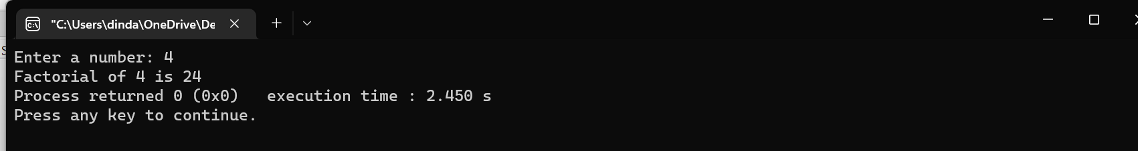

Program 16: C program to convert a given decimal no to its equivalent binary no using function call.
#include <stdio.h>

void decimalToBinary(int decimal) {
if (decimal == 0)
return;

decimalToBinary(decimal/2);
printf("%d", decimal%2);
}

int main() {
int decimal;
printf("Enter a decimal number: ");
scanf("%d", &decimal);
printf ("\n binary equivalent no is ");
decimalToBinary(decimal);
printf("\n");
return 0;
}

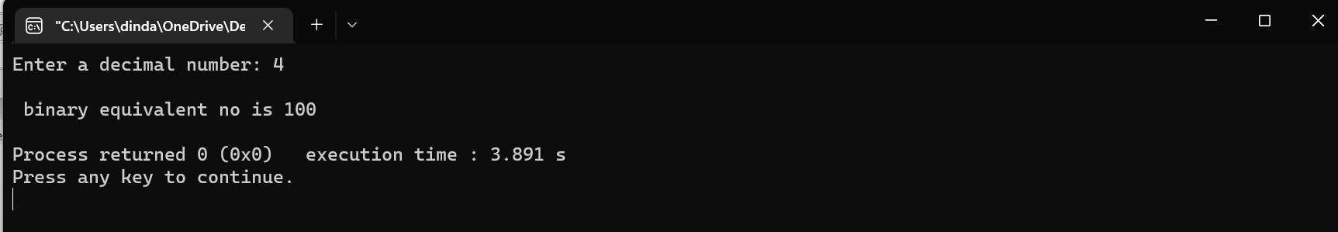

Program 17: C program to swap the values of two variables using function call.
#include <stdio.h>

void swap(int *a, int *b) {
int temp = *a;
*a = *b;
*b = temp;
}

int main() {
int x, y;
printf("Enter two numbers: ");
scanf("%d%d", &x, &y);
printf("Before swapping: x = %d, y = %d\n", x, y);
swap(&x, &y);
printf("After swapping: x = %d, y = %d", x, y);
return 0;
}

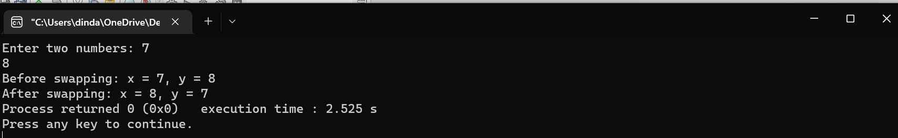

Program 18: C program to print the Fibonacci series between 1 to n using function call.
#include <stdio.h>

void fibonacci(int n) {
int i, a = 0, b = 1, c;
if (n < 1)
return;
printf("%d ", b);
for (i = 2; i <= n; i++) {
c = a + b;
printf("%d ", c);
a = b;
b = c;
}
}

int main() {
int n;
printf("Enter a number: ");
scanf("%d", &n);
fibonacci(n);
printf("\n");
return 0;
}

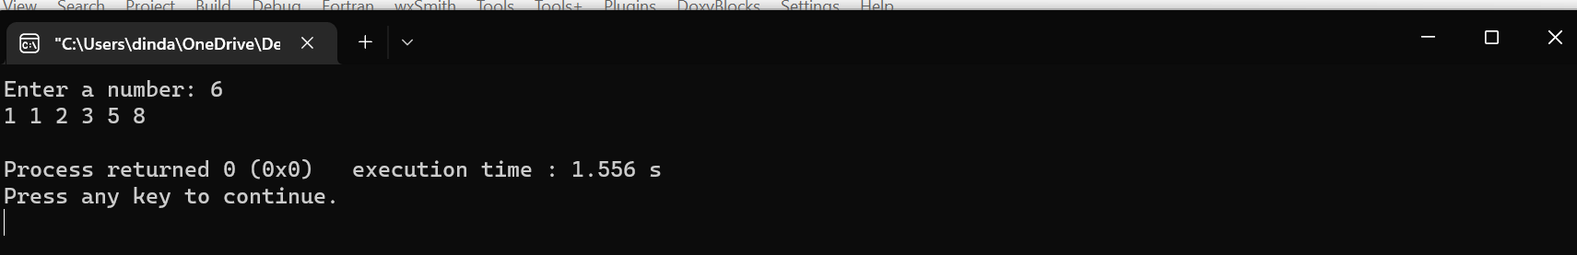

Program 19: C program to store and display the details of a book using structure.
#include <stdio.h>
#include <string.h>

struct book {
char title[50];
char author[50];
char publisher[50];
int pages;
float price;
};

int main() {
struct book b;
printf("Enter details of a book:\n");
printf("Title: ");
scanf("%[^\n]s", b.title);
getchar();
printf("Author: ");
fgets(b.author, sizeof(b.author), stdin);
b.author[strcspn(b.author, "\n")] = 0;
printf("Publisher: ");
fgets(b.publisher, sizeof(b.publisher), stdin);
b.publisher[strcspn(b.publisher, "\n")] = 0;
printf("Pages: ");
scanf("%d", &b.pages);
printf("Price: ");
scanf("%f", &b.price);

printf("\nBook details:\n");
printf("Title: %s\n", b.title);
printf("Author: %s\n", b.author);
printf("Publisher: %s\n", b.publisher);
printf("Pages: %d\n", b.pages);
printf("Price: %.2f\n", b.price);

return 0;
}

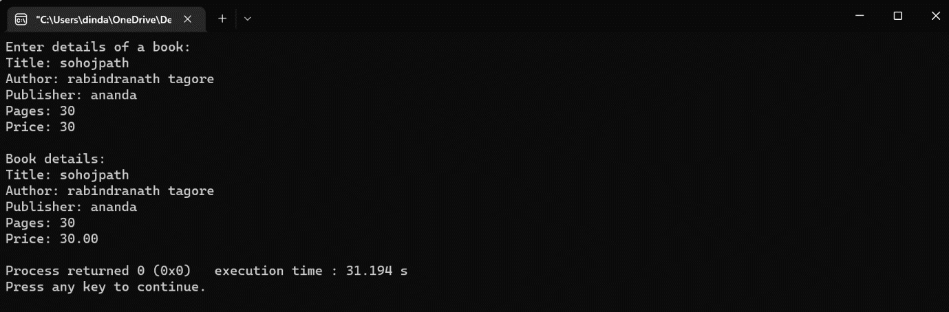

Program 20: C program to store items and find the name of the item with maximum quantity in the store using structure.
#include <stdio.h>

struct Item {
char name[20];
int quantity;
};

int main() {
struct Item items[3];
int i;
int maxQuantityIndex = 0;

for (i = 0; i < 3; i++) {
printf("Enter item name: ");
scanf("%s", items[i].name);
printf("Enter item quantity: ");
scanf("%d", &items[i].quantity);
}

for (i = 0; i < 3; i++) {
if (items[i].quantity > items[maxQuantityIndex].quantity) {
maxQuantityIndex = i;
}
}

printf("Item with maximum quantity: %s\n", items[maxQuantityIndex].name);

return 0;
}
